
MAHATMA EDUCATION SOCIETY’S
PILLAI COLLEGE OF ARTS, COMMERCE & SCIENCE
(AUTONOMS) NEW PANVEL

PROJECT REPORT CORE JAVA
ReportGen – STUDENT REPORT CARD MANAGEMENT SYSTEM

IN PARTIAL FULFILLMENT
BACHELOR OF SCIENCE COMPUTER SCIENCE

SEMESTER II– 2025-26

PROJECT GUIDE
PROFESSOR. KANCHAN SHAH

SUBMITTED BY
KRISHNA KAMLESH SINGH
ROLL NO. 1400
INDEX

CERTIFICATE
INTRODUCTION
NEED OF THE PROJECT
OBJECTIVES OF THE PROJECT
METHODOLOGY
EXPLANATION (SOURCE CODE)
EXPLANATION WITH OUTPUT
SWOT
CONCLUSION

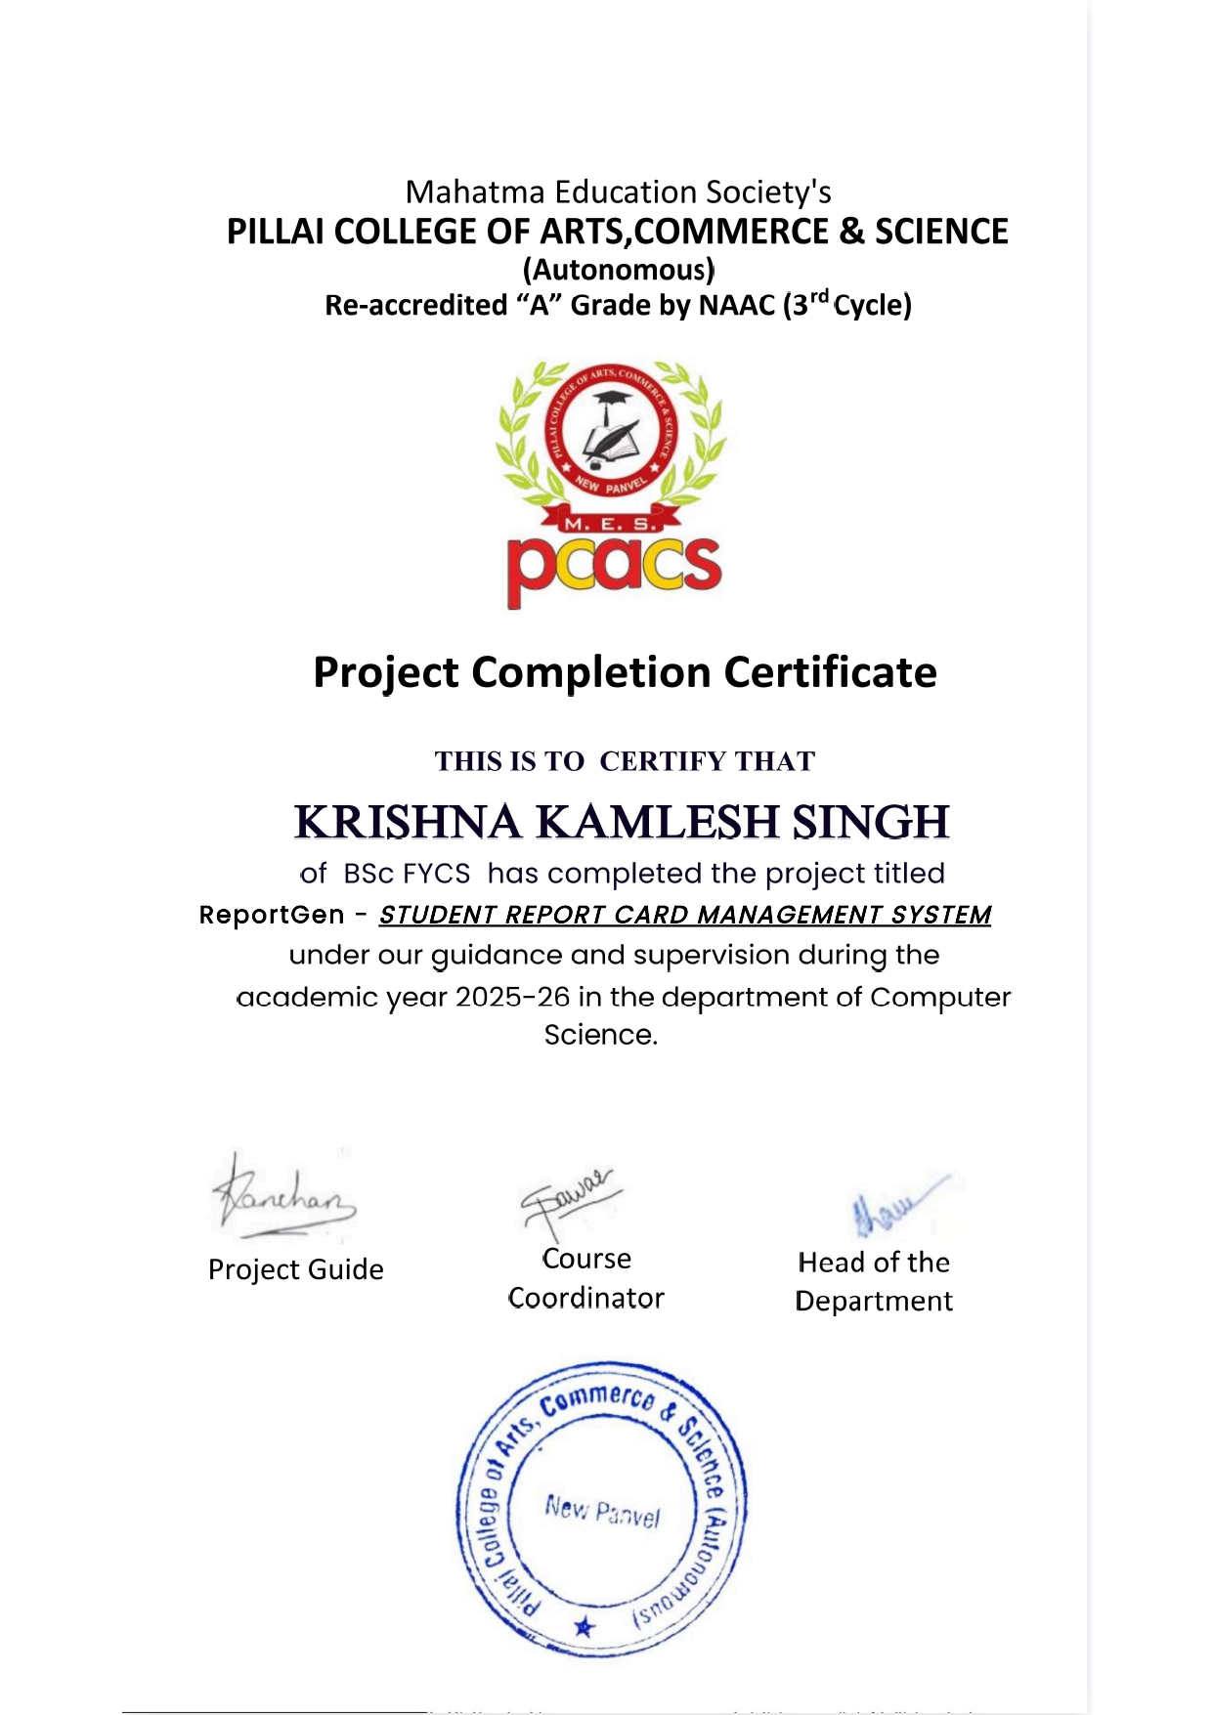

INTRODUCTION
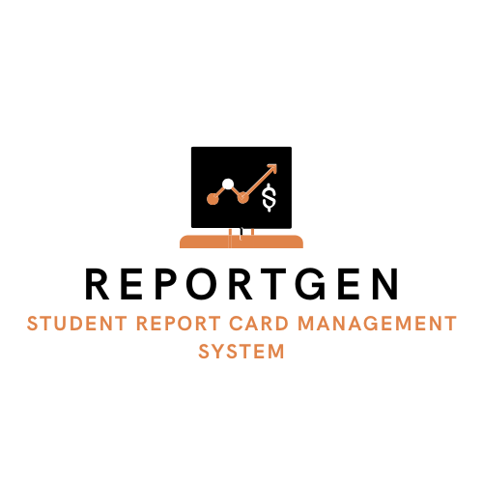
In educational institutions, preparing student report cards is an essential academic activity, but it is often repetitive, time-consuming, and prone to manual errors. Traditional methods of report card preparation involve handwritten entries or basic calculations, which increase the chances of mistakes in total marks, record handling, and data maintenance. As the number of students increases, managing records manually becomes difficult and inefficient. To overcome these limitations, computer-based systems are widely used to automate report generation, improve accuracy, and ensure systematic record management.

ReportGen – Student Report Card Management System is a console-based Java application developed as a Core Java project for FY B.Sc. Computer Science – Semester II. The main objective of this project is to design and implement a simple yet effective system that automates the process of managing student academic records. The application allows an administrator to securely log in, add student details, enter subject-wise marks, generate well-formatted report cards, modify existing records, search students by name, display class-wise student performance, and store all data permanently using file handling techniques.
This project is developed using only Core Java concepts such as Object-Oriented Programming, arrays, ArrayList, file handling, serialization, and exception handling. It does not depend on any external databases or graphical user interfaces, which keeps the system lightweight, easy to understand, and suitable for academic learning at the undergraduate level. By implementing ReportGen – Student Report Card Management System, students gain practical exposure to real-life applications of Java programming and develop a clear understanding of how software systems can be used to solve everyday administrative problems in educational institutions.

NEED OF THE PROJECT
The need for this project arises due to the following reasons:
- Manual report card preparation is time-consuming.
- There is a high chance of human error in total calculations.
- Student records need to be stored and retrieved efficiently.
- Teachers and administrators require quick access to student performance.
- Practical understanding of Core Java concepts is required at FY level.
This project provides a simple solution to manage and generate student report cards accurately.

OBJECTIVES OF THE PROJECT
- To develop a Java-based student report card system.
- To implement admin authentication for security.
- To generate report cards using roll number.
- To allow modification of student details and marks.
- To search students by name.
- To display class-wise student performance.
- To store student data permanently using file handling.

METHODOLOGY
The methodology describes the systematic approach followed to design, develop, test, and implement the Student Report Card Generator project. This project was developed using a step-by-step procedure to ensure clarity, correctness, and proper use of Core Java concepts.

Requirement Analysis
At the initial stage, the requirements of the system were identified. The main requirements included:
- Secure admin login system
- Ability to add and manage student details
- Support for internal and external marks pattern
- Generation of formatted report cards
- Searching and modifying student records
- Permanent storage of data
These requirements were finalized keeping in mind the academic syllabus and real-life school report card system.

System Design Planning
After analyzing the requirements, the system design was planned. The application was divided into different modules such as Admin authentication, Student data management, Report generation, Search, Modification, and File handling. A menu-driven approach was selected to make the system user-friendly and easy to operate through the console.

Implementation Using Core Java
The system was implemented using Core Java concepts only. Object-Oriented Programming principles such as classes, objects, encapsulation, and methods were used. Arrays and ArrayList were used to store subject details and multiple student records. File handling with serialization was implemented to save and load student data from a file.

Testing and Execution
Each module of the program was tested individually by providing valid and invalid inputs. Sample student records were added, report cards were generated, modifications were performed, and search operations were tested. The output obtained on the Command Prompt was verified with expected results to ensure correct working of the system.

Data Storage and Validation
Student records were stored in a file using ObjectOutputStream, and retrieved using ObjectInputStream. Validation checks such as duplicate roll number prevention and correct input types were performed to maintain data integrity.
Result Verification
The final output, including report cards, search results, and class-wise lists, was verified using real execution data. Screenshots of successful execution were captured and included in the report as evidence of correct implementation.
This structured methodology helped in developing a reliable, organized, and efficient Core Java application.

EXPLANATION OF SOURCE CODE

import java.io.*;
import java.util.*;

class Admin {
static final String USERNAME = "admin";
static final String PASSWORD = "admin123";
}

class Student implements Serializable {

String college = "Sainath High School and Jr College";
int rollNo, studentClass;
String name;

int subjectCount;
String[] subjects;
int[] internalMarks;
int[] externalMarks;
int[] totalMarks;

boolean hasInternal;

Student(int subjectCount, boolean hasInternal) {
this.subjectCount = subjectCount;
this.hasInternal = hasInternal;

subjects = new String[subjectCount];
internalMarks = new int[subjectCount];
externalMarks = new int[subjectCount];
totalMarks = new int[subjectCount];
}

void calculateTotals() {
for (int i = 0; i < subjectCount; i++) {
totalMarks[i] = internalMarks[i] + externalMarks[i];
}
}

int totalObtained() {
int sum = 0;
for (int t : totalMarks) sum += t;
return sum;
}

void displayReport() {
calculateTotals();

System.out.println("\n========================================================");
System.out.println(" " + college.toUpperCase());
System.out.println(" REPORT CARD");
System.out.println("========================================================");
System.out.printf(" Roll No : %-10d Class : %d\n", rollNo, studentClass);
System.out.println(" Name : " + name);
System.out.println("--------------------------------------------------------");

if (hasInternal) {
System.out.printf("%-15s %-10s %-10s %-10s\n",
"Subject", "Internal", "External", "Total");
} else {
System.out.printf("%-15s %-10s\n", "Subject", "Marks");
}

System.out.println("--------------------------------------------------------");

for (int i = 0; i < subjectCount; i++) {
if (hasInternal) {
System.out.printf("%-15s %-10d %-10d %-10d\n",
subjects[i], internalMarks[i], externalMarks[i], totalMarks[i]);
} else {
System.out.printf("%-15s %-10d\n",
subjects[i], externalMarks[i]);
}
}

System.out.println("--------------------------------------------------------");
System.out.println(" TOTAL MARKS OBTAINED : " + totalObtained());
System.out.println("========================================================");
}
}

public class StudentReportCardAdvanced {

static final String FILE_NAME = "students.dat";
static Scanner sc = new Scanner(System.in);
static ArrayList<Student> students = new ArrayList<>();

public static void main(String[] args) {

if (!adminLogin()) return;

loadStudents();

System.out.print("Is internal & external pattern was followed in Examination? (yes/no): ");
boolean hasInternal = sc.next().equalsIgnoreCase("yes");

while (true) {
System.out.println("\n===== MENU =====");
System.out.println("1. Add Student");
System.out.println("2. Generate Report by Roll No");
System.out.println("3. Modify Report by Roll No");
System.out.println("4. Search Student by Name");
System.out.println("5. Class-wise Student List");
System.out.println("6. Exit");
System.out.print("Choose option: ");

int choice = sc.nextInt();

switch (choice) {
case 1 -> addStudent(hasInternal);
case 2 -> generateReport();
case 3 -> modifyReport();
case 4 -> searchByName();
case 5 -> classWiseList();
case 6 -> {
saveStudents();
System.out.println("Data saved. Exiting...");
return;
}
default -> System.out.println("Invalid choice.");
}

}
}

static boolean adminLogin() {
System.out.print("Admin Username: ");
String u = sc.next();
System.out.print("Admin Password: ");
String p = sc.next();

if (u.equals(Admin.USERNAME) && p.equals(Admin.PASSWORD)) {
System.out.println("Login successful.\n");
return true;
}
System.out.println("Invalid login.");
return false;
}

static void addStudent(boolean hasInternal) {

System.out.print("Roll No: ");
int roll = sc.nextInt();
sc.nextLine();

for (Student s : students) {
if (s.rollNo == roll) {
System.out.println("Roll No already exists.");
return;
}
}

System.out.print("Name: ");
String name = sc.nextLine();

System.out.print("Class (1-12): ");
int cls = sc.nextInt();

System.out.print("Number of subjects: ");
int subCount = sc.nextInt();
sc.nextLine();

Student s = new Student(subCount, hasInternal);
s.rollNo = roll;
s.name = name;
s.studentClass = cls;

for (int i = 0; i < subCount; i++) {
System.out.print("Subject " + (i + 1) + ": ");
s.subjects[i] = sc.nextLine();
}

if (hasInternal) {
for (int i = 0; i < subCount; i++) {
System.out.print("Internal marks (" + s.subjects[i] + "): ");
s.internalMarks[i] = sc.nextInt();
}
}

for (int i = 0; i < subCount; i++) {
System.out.print("Marks (" + s.subjects[i] + "): ");
s.externalMarks[i] = sc.nextInt();
}

students.add(s);
System.out.println("Student added.");
}

static void generateReport() {
System.out.print("Enter Roll No: ");
int roll = sc.nextInt();

for (Student s : students) {
if (s.rollNo == roll) {
s.displayReport();
return;
}
}
System.out.println("Student not found.");
}

static void searchByName() {
sc.nextLine();
System.out.print("Enter student name: ");
String searchName = sc.nextLine();

boolean found = false;
for (Student s : students) {
if (s.name.equalsIgnoreCase(searchName)) {
s.displayReport();
found = true;
}
}

if (!found) {
System.out.println("Student not found.");
}
}

static void classWiseList() {
System.out.print("Enter class (1-12): ");
int cls = sc.nextInt();

boolean found = false;

System.out.println("\nROLL NO NAME TOTAL MARKS");
System.out.println("------------------------------------------------");

for (Student s : students) {
if (s.studentClass == cls) {
s.calculateTotals(); // ensure totals are updated

System.out.printf("%-9d %-22s %-10d\n",
s.rollNo,
s.name,
s.totalObtained());

found = true;
}
}

if (!found) {
System.out.println("No students found for this class.");
}
}

static void modifyReport() {
System.out.print("Enter Roll No: ");
int roll = sc.nextInt();

for (Student s : students) {
if (s.rollNo == roll) {

while (true) {
System.out.println("\n--- MODIFY MENU ---");
System.out.println("1. Change Name");
System.out.println("2. Change Roll No");
System.out.println("3. Change Subject Name");
System.out.println("4. Change Internal Marks");
System.out.println("5. Change External Marks");
System.out.println("6. Back");
System.out.print("Choose: ");

int ch = sc.nextInt();

switch (ch) {
case 1 -> {
sc.nextLine();
System.out.print("New Name: ");
s.name = sc.nextLine();
System.out.println("Name updated.");
}

case 2 -> {
System.out.print("New Roll No: ");
s.rollNo = sc.nextInt();
System.out.println("Roll No updated.");
}

case 3 -> {
for (int i = 0; i < s.subjectCount; i++) {
System.out.println((i + 1) + ". " + s.subjects[i]);
}
System.out.print("Select subject: ");
int idx = sc.nextInt() - 1;
sc.nextLine();
System.out.print("New Subject Name: ");
s.subjects[idx] = sc.nextLine();
System.out.println("Subject updated.");
}

case 4 -> {
if (!s.hasInternal) {
System.out.println("Internal marks not applicable.");
break;
}
for (int i = 0; i < s.subjectCount; i++) {
System.out.println((i + 1) + ". " + s.subjects[i]);
}
System.out.print("Select subject: ");
int idx = sc.nextInt() - 1;
System.out.print("New Internal Marks: ");
s.internalMarks[idx] = sc.nextInt();
System.out.println("Internal marks updated.");
}

case 5 -> {
for (int i = 0; i < s.subjectCount; i++) {
System.out.println((i + 1) + ". " + s.subjects[i]);
}
System.out.print("Select subject: ");
int idx = sc.nextInt() - 1;
System.out.print("New External Marks: ");
s.externalMarks[idx] = sc.nextInt();
System.out.println("External marks updated.");
}

case 6 -> {
return;
}

default -> System.out.println("Invalid option.");
}
}
}
}
System.out.println("Student not found.");
}

static void saveStudents() {
try (ObjectOutputStream oos = new ObjectOutputStream(new FileOutputStream(FILE_NAME))) {
oos.writeObject(students);
} catch (Exception e) {
System.out.println("Error saving data.");
}
}

static void loadStudents() {
try (ObjectInputStream ois = new ObjectInputStream(new FileInputStream(FILE_NAME))) {
students = (ArrayList<Student>) ois.readObject();
System.out.println("Students loaded from previous session.");
} catch (Exception e) {
System.out.println("No previous data found.");
}
}
}

1. Import Statements
import java.io.*;
import java.util.*;

These import statements allow the program to use predefined Java classes:
- The java.util package provides utility classes such as Scanner for input and ArrayList for dynamic storage of student records.
- The java.io package is used for file handling and serialization, which helps in saving and loading student data permanently.

2. Admin Class
class Admin {
static final String USERNAME = "admin";
static final String PASSWORD = "admin123";
}

The Admin class is used for authentication purposes.
- It stores the admin username and password.
- The use of static final makes these values constant and secure.
- These credentials are checked during login before the admin can access the system.
This class adds a basic level of security to the application.

3. Student Class
class Student implements Serializable

The Student class represents a student record.
- It implements the Serializable interface so that student objects can be written to a file.
- Serialization allows complete student data to be stored and retrieved easily.

3.1 Variables in Student Class
The Student class contains the following data members:
- college – Stores the name of the institution.
- rollNo – Stores the roll number of the student.
- studentClass – Stores the class or standard of the student.
- name – Stores the student’s name.
- subjectCount – Stores the number of subjects.
- subjects[] – Stores subject names.
- internalMarks[] – Stores internal marks.
- externalMarks[] – Stores external marks.
- totalMarks[] – Stores total marks for each subject.
- hasInternal – Indicates whether internal marks are applicable.

3.2 Constructor of Student Class
Student(int subjectCount, boolean hasInternal)

- Initializes a Student object.
- Creates arrays dynamically based on the number of subjects.
- Stores whether the examination pattern includes internal marks.
This makes the program flexible for different students and examination systems.

3.3 calculateTotals() Method
void calculateTotals()

- Calculates the total marks for each subject.
- Adds internal marks and external marks.
- Ensures accurate and automatic calculation of totals.

3.4 totalObtained() Method
int totalObtained()

- Calculates the total marks obtained by the student in all subjects.
- Used in report card display and class-wise student list.

3.5 displayReport() Method
The displayReport() method generates the student report card.
- Displays college name, roll number, class, and student name.
- Shows subject-wise marks in a tabular format.
- Automatically changes format based on internal/external marks pattern.
- Displays total marks obtained at the end.
This method is responsible for producing the final report card output on the console.

4. Main Class – StudentReportCardAdvanced
This is the main class of the application and controls the overall program execution.

4.1 Static Variables
static final String FILE_NAME = "students.dat";
static Scanner sc = new Scanner(System.in);
static ArrayList<Student> students = new ArrayList<>();

- FILE_NAME stores the name of the file used for saving student data.
- Scanner is used to accept user input from the keyboard.
- ArrayList stores multiple student objects dynamically.

4.2 main() Method
The main() method is the entry point of the program.
- Performs admin login verification.
- Loads previously saved student data from file.
- Accepts examination pattern (internal and external marks).
- Displays a menu-driven interface using a loop.
The program continues running until the user chooses the exit option.

4.3 adminLogin() Method
- Accepts username and password from the user.
- Compares them with admin credentials.
- Allows or denies access accordingly.

4.4 addStudent() Method
- Accepts student details such as roll number, name, class, subjects, and marks.
- Checks for duplicate roll numbers.
- Creates a Student object and stores it in the ArrayList.

4.5 generateReport() Method
- Accepts roll number as input.
- Searches for the student in the list.
- Calls displayReport() to show the report card.

4.6 searchByName() Method
- Searches student records using name (case-insensitive).
- Displays report cards of all matching students.

4.7 classWiseList() Method
- Displays roll number, name, and total marks of students belonging to a specific class.
- Helps in comparing student performance class-wise.

4.8 modifyReport() Method
This method allows modification of existing student records:
- Change student name
- Change roll number
- Modify subject names
- Update internal and external marks
It ensures easy correction and updating of records.

5. File Handling and Data Persistence

5.1 saveStudents() Method
- Saves all student objects into a file using ObjectOutputStream.
- Ensures permanent storage of data.

5.2 loadStudents() Method
- Loads saved student records using ObjectInputStream.
- Prevents loss of data when the program is restarted.

6. Summary
This source code uses Core Java concepts such as classes, objects, arrays, ArrayList, file handling, serialization, and menu-driven programming. The structured approach makes the program easy to understand, maintain, and extend in the future.

SAMPLE OUTPUT SCREENS
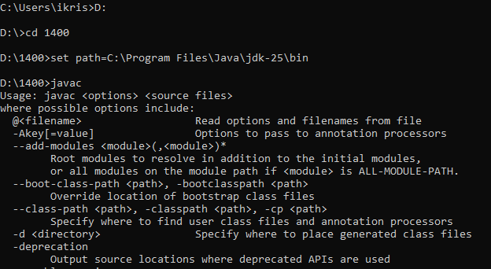
Setting up of path

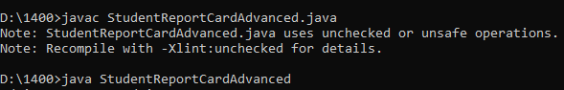
File compiles
RUNNING OF MAIN FILE
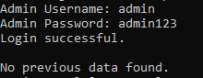
Login part as added into source code

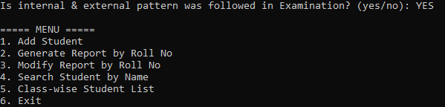
First input taken from user: Examination Pattern Followed
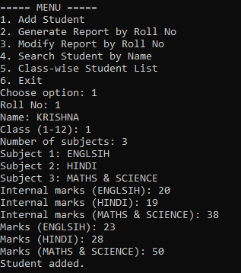

Second input taken from user: Choose particular option to continue


Choose option 1



Adding of student details with Internal as well as External Marks, followed with Name, Class
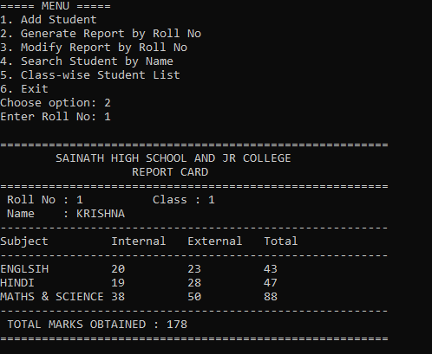
Generated Report with External and Internal Markings 1.1
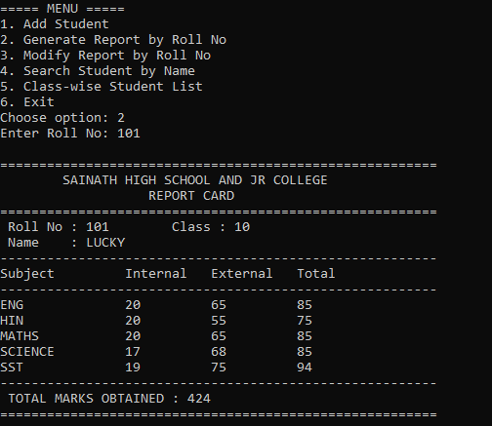
Generated Report with External and Internal Markings 1.2

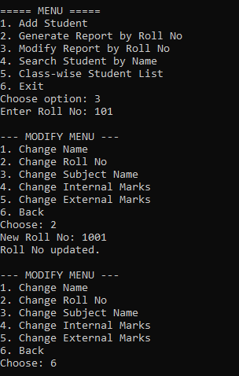

Choose Option 3 for Modification


Modification for Roll no 101, New Roll no 1001
I also changed Subject name (from SST to Social Science), student’s name (from Lucky to Himanshu) and Internal and External Marking for Social Science
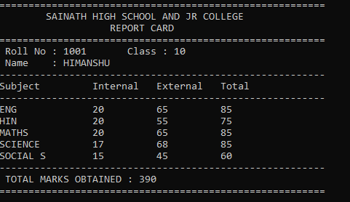
Modified Report

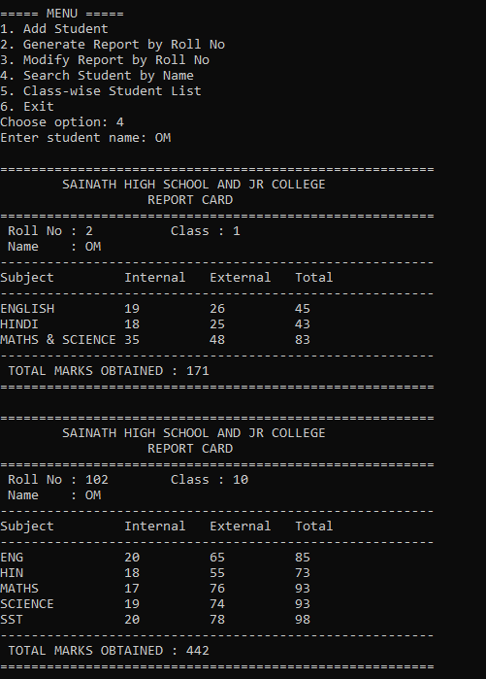
Search of Report on Basis of Name

Choose option 4, then enter student’s Name
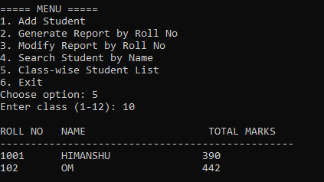
For Class wise report choose option 5, then enter Class


Class wise report will be shown

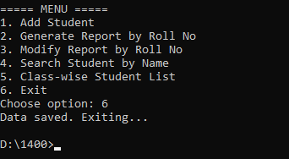
Choose option 6 for exit all performed activity will be saved as file
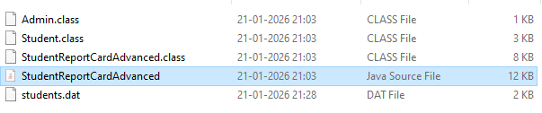
Folder structure and saved files

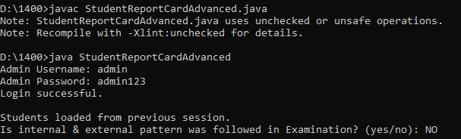

Re-Login, our all previous data was saved

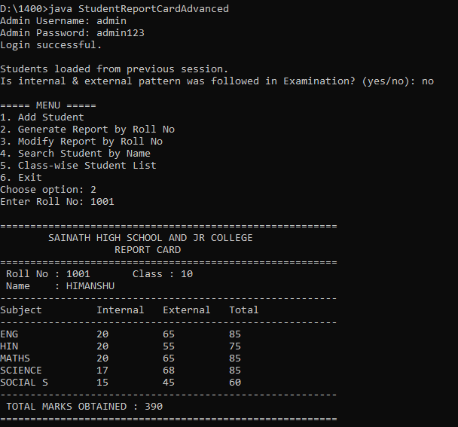

Regenerating a report on basis on previous filling

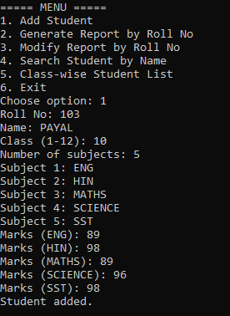
Adding of student details without Internal and External Marks, followed with Name, Class

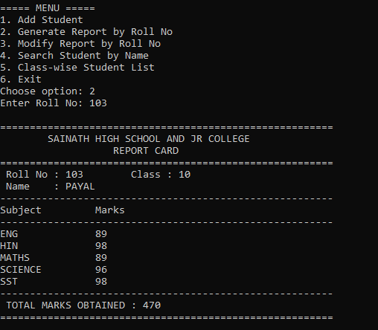
Generated Report without External and Internal Markings 1.1

SWOT ANALYSIS

Strengths
- Developed using Core Java concepts such as OOP, ArrayList, file handling, serialization, and exception handling, making it academically strong.
- Automates report card generation, reducing manual effort and calculation errors.
- Persistent data storage using file handling ensures data is not lost between sessions.
- Menu-driven, user-friendly console interface that is easy to operate for beginners.
- Supports internal and external marks patterns, making the system flexible.

Weaknesses
- Application is console-based only, which limits usability and visual appeal.
- Single admin user with hardcoded credentials reduces security and scalability.
- No percentage, grade, or result classification (Pass/Fail) calculation.
- Data storage uses files instead of a database, which is not suitable for large datasets.
- Limited input validation for marks range and subject constraints.
- Not suitable for multi-user or network-based environments.

Opportunities
- Can be enhanced with a GUI using Swing or JavaFX for better user experience.
- Integration with a database (MySQL/SQLite) for scalable and secure data management.
- Can include percentage, grade, GPA, and ranking features.
- Report cards can be exported to PDF or Excel, increasing practical usability.
- Can be extended into a full-fledged school/college management system.
- Provides a strong foundation for learning advanced Java and software development practices.

Threats
- Modern institutions prefer web-based or cloud-based systems, reducing relevance of console applications.
- Risk of data corruption or loss if the data file is accidentally deleted or damaged.
- Hardcoded credentials may pose security risks if used beyond academic purposes.
- Competing systems with databases and GUIs offer more features and better performance.
- Changes in academic evaluation systems may require frequent updates to the logic.

CONCLUSION
The Student Report Card Generator project successfully demonstrates the practical application of Core Java programming concepts in developing a real-world, problem-oriented software system. The primary objective of this project was to automate the traditional and error-prone process of student report card preparation, and this objective has been effectively achieved through a structured, menu-driven Java application.
The system provides a reliable solution for managing student academic records by allowing secure admin authentication, efficient student data entry, accurate subject-wise mark calculation, and well-formatted report card generation. By automating calculations and data handling, the system significantly reduces human errors commonly associated with manual report preparation. Features such as searching student records by name, class-wise performance display, and modification of existing records further enhance the usability and practicality of the application.
A major strength of this project is the exclusive use of Core Java concepts, including Object-Oriented Programming principles such as classes, objects, encapsulation, and methods, along with arrays, ArrayList, file handling, serialization, and exception handling. The implementation of file handling ensures persistent storage of data, preventing data loss even after program termination. This approach helps in understanding how real-world applications manage and preserve data efficiently.
From a learning perspective, this project has greatly enhanced practical understanding of Java programming, logical thinking, and software development methodology. It bridges the gap between theoretical knowledge and real-world application by demonstrating how programming concepts can solve everyday administrative problems in educational institutions.
In conclusion, the Student Report Card Generator is a successful academic project that fulfills its intended objectives and serves as a strong foundation for understanding Core Java application development. It not only demonstrates technical competence but also contributes significantly to building confidence in developing efficient, reliable, and maintainable software systems

1400. KRISHNA K SINGH
FY B.Sc. Computer Science – Semester II

